FINANCIAL SYSTEMS RESEARCH
Financial Management System
Jordan Business & Accounting Management Research

Table of Contents
Table of Contents [1](#table-of-contents)
Introduction [1](#_Toc237256193)
Business Plan Development تطوير خطة العمل [1](#business-plan-development-تطوير-خطة-العمل)
Account Reconciliation مطابقة الحسابات [1](#account-reconciliation-مطابقة-الحسابات)
Account Management إدارة الحسابات [1](#account-management-إدارة-الحسابات)
Internal Controls Implementation تنفيذ الضوابط الداخلية [1](#internal-controls-implementation-تنفيذ-الضوابط-الداخلية)
Tender / Bid Auditing تدقيق على العطاءات [1](#tender-bid-auditing-تدقيق-على-العطاءات)
Cash Flow Improvement تحسين التدفق النقدي [1](#cash-flow-improvement-تحسين-التدفق-النقدي)
Social Security الضمان الاجتماعي [1](#social-security-الضمان-الاجتماعي)
Income Tax Preparation إعداد ضريبة الدخل [1](#income-tax-preparation-إعداد-ضريبة-الدخل)
Fixed Assets الأصول الثابتة [1](#fixed-assets-الأصول-الثابتة)
Expense Classification & Management تصنيف المصروف وإدارتها [1](#expense-classification-management-تصنيف-المصروف-وإدارتها)
Deduction Calculation حساب الاقتطاعات [1](#deduction-calculation-حساب-الاقتطاعات)
Payroll Processing / Salary Issuance إصدار الرواتب [1](#payroll-processing-salary-issuance-إصدار-الرواتب)
Monitoring Tax Exemptions & Tax Updates متابعة نزول الإعفاءات والضرائب [1](#monitoring-tax-exemptions-tax-updates-متابعة-نزول-الإعفاءات-والضرائب)
Fixed Expenses المصاريف الثابتة [1](#fixed-expenses-المصاريف-الثابتة)
Reporting Concepts التقارير [1](#reporting-concepts-التقارير)
Written Financial Policy سياسة مالية مكتوبة [1](#written-financial-policy-سياسة-مالية-مكتوبة)
How the Topics Connect [1](#how-the-topics-connect)
Closing Note & Next Step [1](#_Toc237256211)
Introduction
This document explains the financial and accounting topics that must be understood before software requirements are written. For each topic, it describes what the process is, why it matters, how it normally works in practice, the main data or documents involved, and a practical example.
Important
This document includes the current Jordanian tax, social-security, and other statutory rates relevant to the financial processes discussed. These figures are provided as a business reference based on the applicable rules at the time of this research. As rates, exemptions, thresholds, and regulations may change, they should be verified against the latest official Jordanian regulations before being applied. Company-specific approval limits and internal policies should also be confirmed during the Requirements phase.

1 | Business Plan Development تطوير خطة العمل
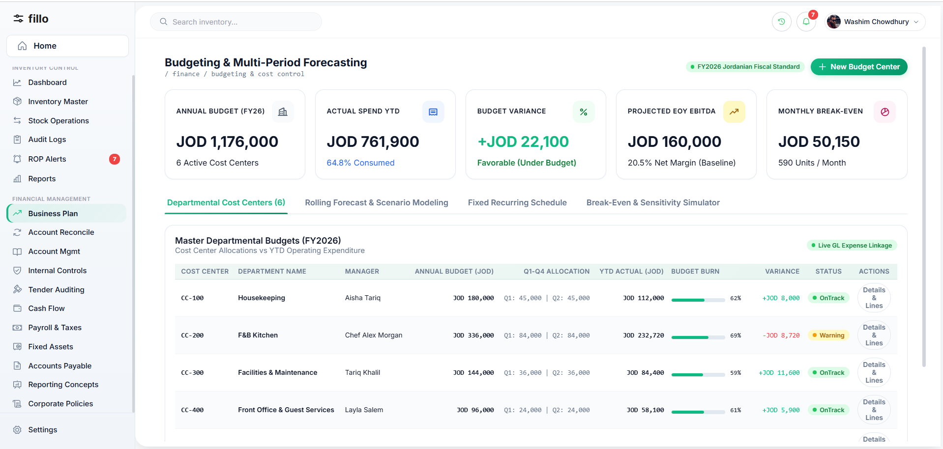
Topic 1 Feature Screenshot
A financial business plan translates management goals into expected revenue, costs, cash needs, budgets and forecasts. It creates a baseline that management can compare with actual performance and helps identify funding needs before problems occur.
How It Works in Practice
STEP 1  Management defines goals and the planning period. | STEP 2  Finance reviews historical results and gathers assumptions for sales, pricing, staffing, rent, operating costs and planned investments.
STEP 3  Revenue, expense and monthly cash-flow estimates are prepared and reviewed. | STEP 4  The approved budget becomes the baseline; actual results are compared with it and significant variances are investigated.
STEP 5
Forecasts may be updated as conditions change, while the original approved budget remains available for comparison.

Key Data & Documents  Prior-year results, sales assumptions, cost estimates, staffing plans, capital spending and financing assumptions. | Practical Example  A company plans a new branch. Finance estimates setup cost, monthly rent, salaries, utilities and expected sales. The cash forecast shows that the branch will require head-office funding during its first months, allowing management to plan the cash requirement in advance.

2 | Account Reconciliation مطابقة الحسابات
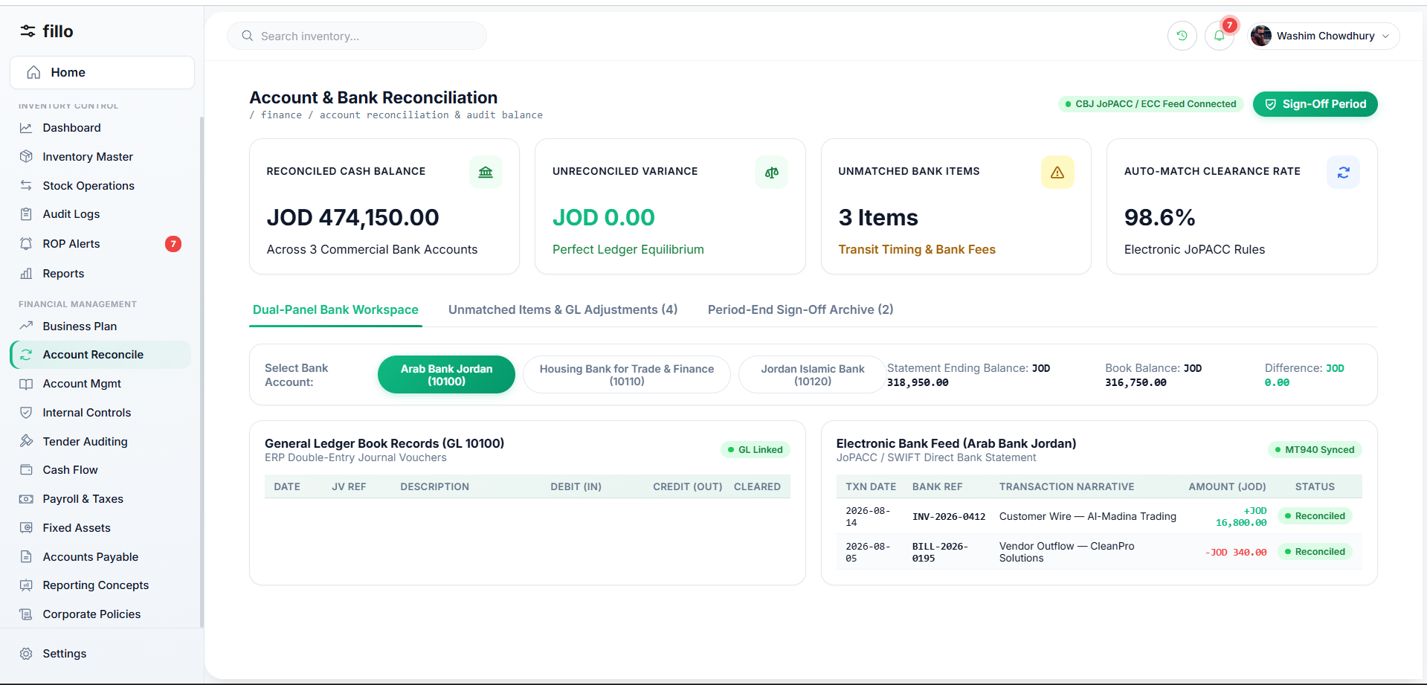
Topic 2 Feature Screenshot
Reconciliation compares the company's accounting record with an independent source, such as a bank, supplier or customer statement. The purpose is to confirm that balances agree or explain every difference.
How It Works in Practice
STEP 1  Select the account and period. | STEP 2  Obtain the independent statement for the same period.
STEP 3  Match transactions by date, amount and reference. | STEP 4  Investigate unmatched items such as timing differences, bank charges, duplicate entries or posting errors.
STEP 5  Post justified adjustments to the books, then recalculate the balances. | STEP 6  A reviewer approves the completed reconciliation before the period is considered closed.

Key Data & Documents  General-ledger detail, external statements, receipts, deposit slips, bank notices and supporting documents for unmatched items. | Practical Example  The cash ledger shows JOD 10,000 and the bank statement JOD 9,800. The accountant identifies a JOD 200 bank fee missing from the books, records it, and the adjusted book balance becomes JOD 9,800.

3 | Account Management إدارة الحسابات
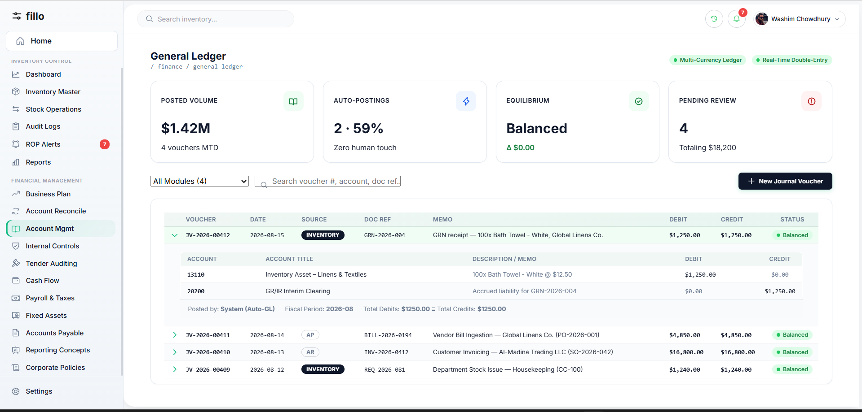
Topic 3 Feature Screenshot
Account management maintains the Chart of Accounts (CoA) and ensures transactions are recorded in the correct asset, liability, equity, revenue or expense accounts. A consistent CoA is essential because reporting, reconciliation, budgeting and tax work all depend on correct classification.
How It Works in Practice
STEP 1  Maintain account codes, names, types and hierarchy. | STEP 2  Create new accounts through a controlled process rather than ad hoc during data entry.
STEP 3  Post transactions to the correct accounts and review account activity regularly. | STEP 4  Investigate unusual balances or amounts left in suspense/clearing accounts.
STEP 5
Deactivate unused accounts instead of deleting them so historical transactions remain traceable.

Key Data & Documents  Chart of Accounts, journal entries, transaction history, invoices, receipts and account status information. | Practical Example  A JOD 2,000 office-rent payment is posted as Debit Rent Expense / Credit Bank. The same posting then flows correctly into expense, cash and management reports.

4 | Internal Controls Implementation تنفيذ الضوابط الداخلية
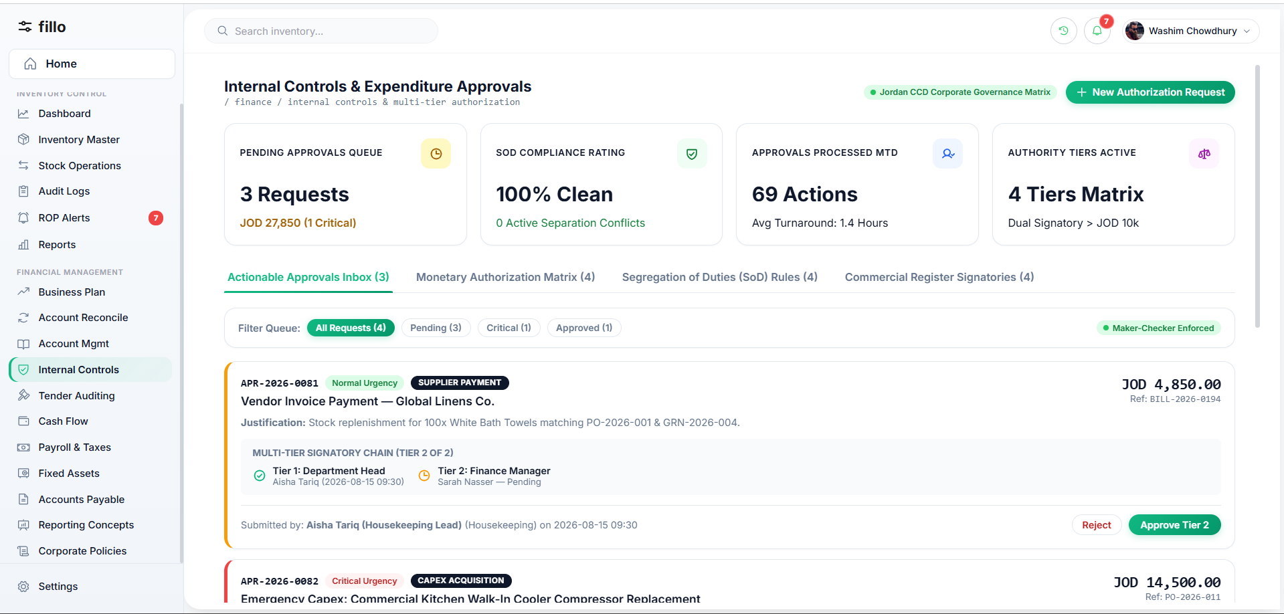
Topic 4 Feature Screenshot
Internal controls are rules that make financial activity authorized, accurate and traceable. They reduce the risk of error or fraud through approvals, segregation of duties, access restrictions, reconciliations and audit trails.
How It Works in Practice
STEP 1  Identify sensitive activities such as large payments, payroll changes, vendor changes and unusual journal entries. | STEP 2  Assign roles so incompatible duties are separated; the person creating a sensitive transaction should not normally approve it.
STEP 3  Apply approval thresholds and route transactions to the required authority. | STEP 4  Record who created, edited, approved, rejected or cancelled each controlled transaction.
STEP 5
Lock closed periods and handle later corrections through controlled adjustments.

Key Data & Documents  User roles, approval matrix, monetary thresholds, audit logs, transaction status and supporting evidence. | Practical Example  An accountant enters a JOD 10,000 supplier payment. Because it exceeds the approval threshold, it remains pending until the Finance Manager reviews and approves it.

5 | Tender / Bid Auditing تدقيق على العطاءات
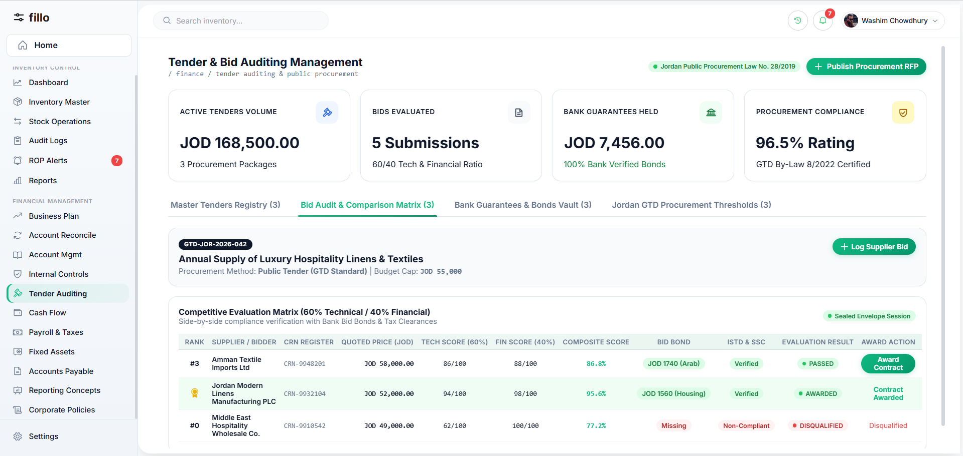
Topic 5 Feature Screenshot
Tender auditing provides a fair, documented financial review of supplier bids. The selected offer should represent the best value against agreed criteria, not automatically the lowest price.
How It Works in Practice
STEP 1  Define the requirement, budget and evaluation criteria before bids are reviewed. | STEP 2  Receive and log supplier offers with price, taxes/fees, payment terms and delivery information.
STEP 3  Compare bids consistently against the agreed criteria and verify budget availability. | STEP 4  Document the evaluation and reason for the selected supplier.
STEP 5
Obtain the required approval and retain all bids, evaluation notes and decisions for audit.

Key Data & Documents  Tender documents, supplier bids, evaluation criteria, pricing schedules, payment terms, budget confirmation and approval records. | Practical Example  Three suppliers quote JOD 20,000, JOD 18,500 and JOD 19,000. The JOD 19,000 offer may be selected if its warranty and delivery score make it the best overall value; the reason is documented and approved.

6 | Cash Flow Improvement تحسين التدفق النقدي
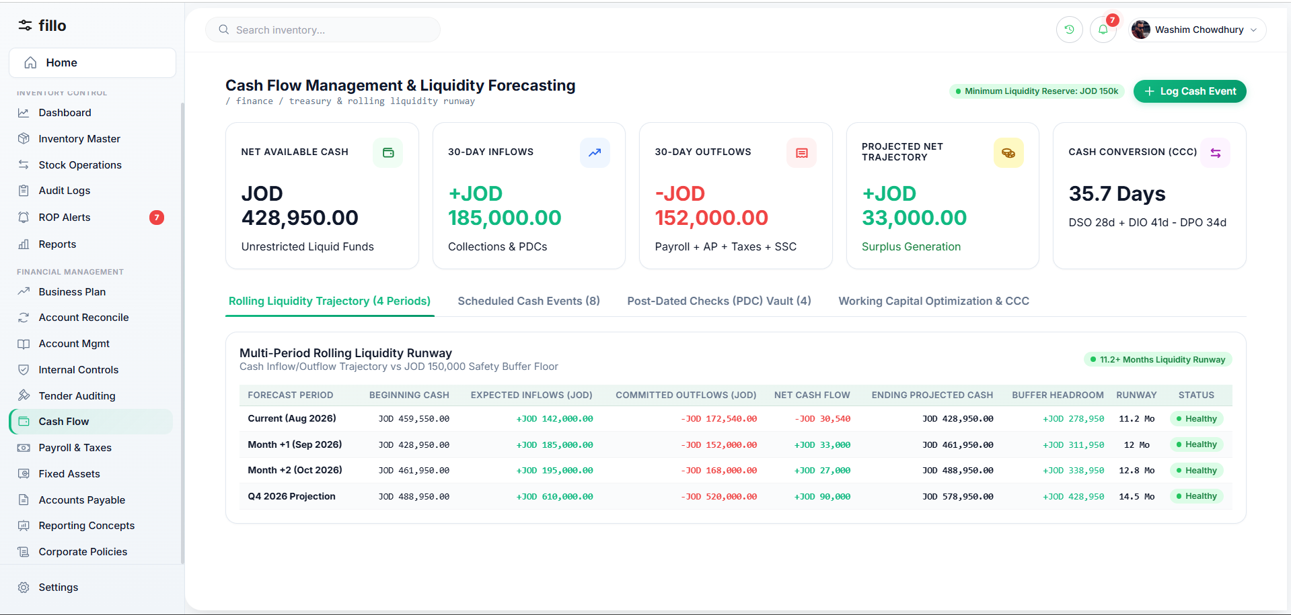
Topic 6 Feature Screenshot
Cash flow focuses on the timing of actual cash receipts and payments. A profitable company can still face a liquidity problem if customers pay later than payroll, suppliers or taxes are due.
How It Works in Practice
STEP 1  Start with current reconciled cash balances. | STEP 2  List expected customer receipts by due date and expected payment behavior.
STEP 3  List planned outflows such as suppliers, payroll, loans, taxes and fixed expenses. | STEP 4  Build a rolling forecast and identify dates where cash may fall below the required level.
STEP 5
Take action before the shortage occurs, then update the forecast as actual receipts and payments happen.

Key Data & Documents  Bank balances, receivable aging, payable due dates, payroll schedules, loan payments, taxes and recurring obligations. | Practical Example  Sales are strong but customers pay on 90-day terms. The forecast identifies an expected JOD 8,000 payroll shortfall several weeks early, giving management time to accelerate collections or arrange funding.

7 | Social Security الضمان الاجتماعي
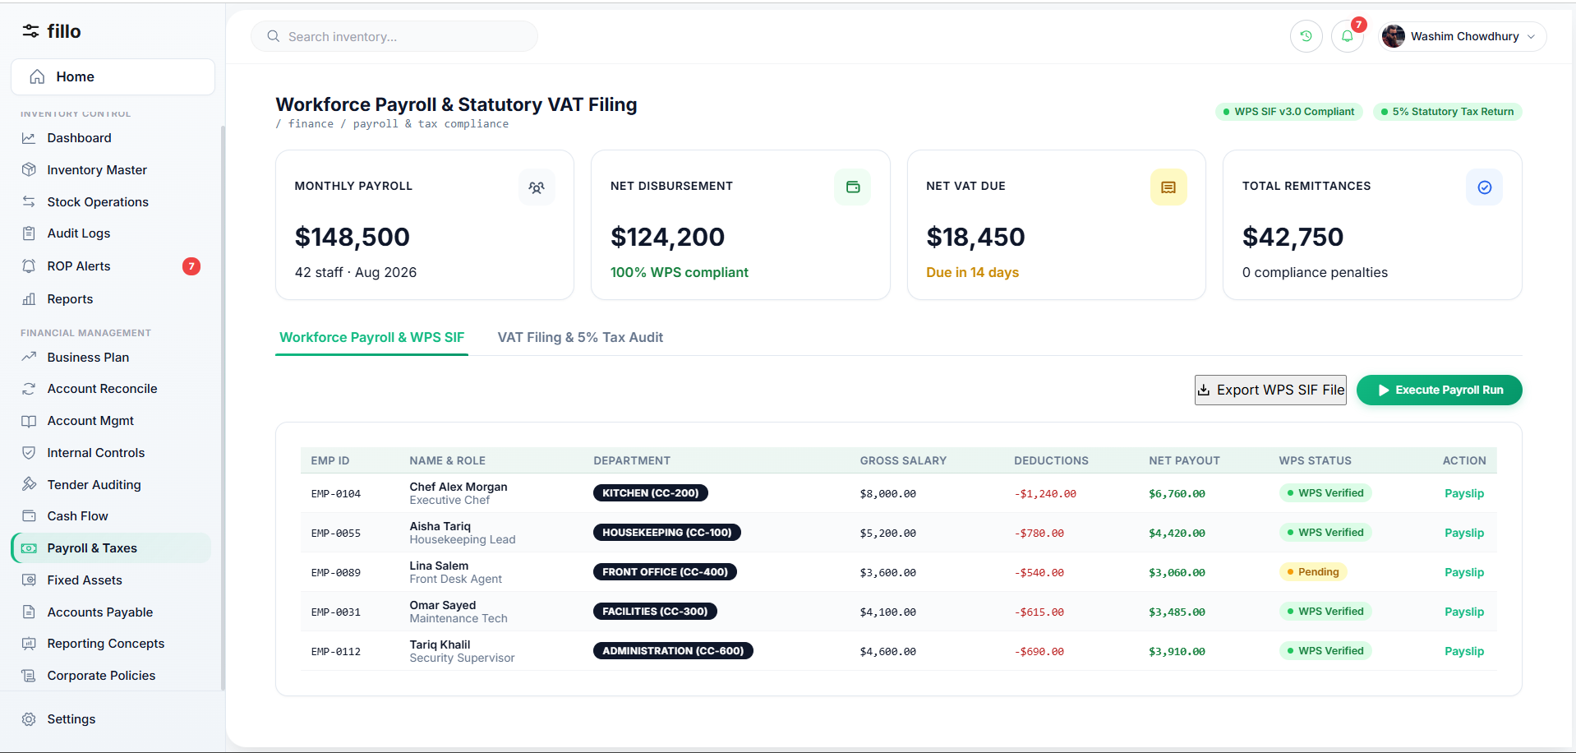
Topic 7 Feature Screenshot
From the finance perspective, social security is part of payroll compliance: applicable employee contributions are deducted from pay and employer contributions are recorded as an additional company cost. Rates and eligibility rules can change and therefore must be tied to an effective rule.
How It Works in Practice
STEP 1  Determine employee eligibility and the rule applicable to the payroll period. | STEP 2  Calculate the employee contribution on the eligible salary basis.
STEP 3  Calculate the employer contribution separately. | STEP 4  Record the employee portion as a payroll deduction and the employer portion as a company expense/liability.
STEP 5
Prepare the records required for payment/reporting and retain the calculation basis.

Key Data & Documents  Employee salary and eligibility data, effective contribution rules, payroll-period calculations and contribution records. | Practical Example  During payroll, the currently approved contribution rule is applied to an eligible employee. Both the employee deduction and employer contribution are recorded with the rule version used for that period.

8 | Income Tax Preparation إعداد ضريبة الدخل
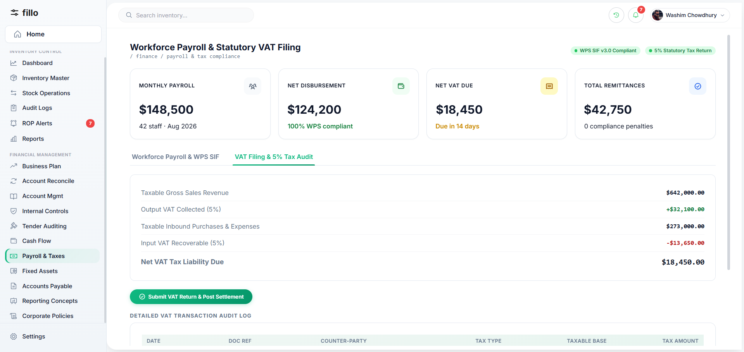
Topic 8 Feature Screenshot
Income-tax preparation organizes accounting results into the information needed to calculate and support the company's tax position. Accounting profit and taxable income can differ because some items require tax-specific treatment or adjustment.
How It Works in Practice
STEP 1  Close and review the accounting period and ensure relevant accounts are reconciled. | STEP 2  Classify revenue and expenses according to their tax treatment.
STEP 3  Identify and document required tax adjustments. | STEP 4  Apply the validated tax rules and exemptions effective for the period.
STEP 5
Calculate the tax position, review it and retain working papers supporting every adjustment.

Key Data & Documents  Reconciled revenue/expense data, tax classifications, fixed-asset/depreciation information, adjustments and the applicable rule version. | Practical Example  At year end, finance starts from accounting profit, identifies any non-deductible items or applicable exemptions, documents the adjustments and derives taxable income with a traceable working paper.

9 | Fixed Assets الأصول الثابتة
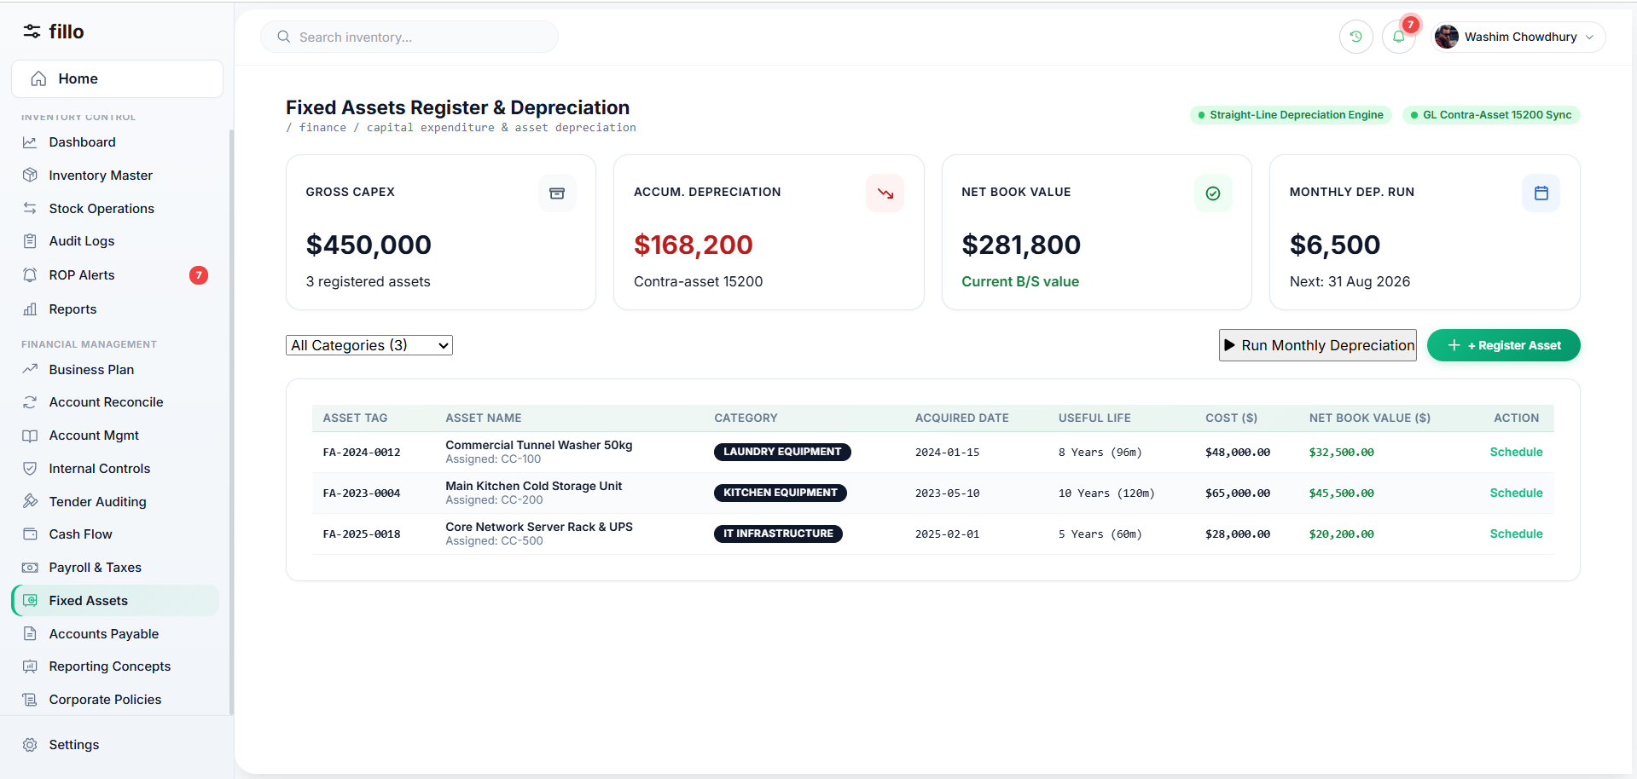
Topic 9 Feature Screenshot
Fixed assets are long-term resources such as equipment, vehicles and furniture. Their cost is normally allocated over their useful life through depreciation rather than treated like an ordinary short-term expense.
How It Works in Practice
STEP 1  Register the asset with cost, acquisition date, category and location/custodian. | STEP 2  Assign the approved useful life, residual value where applicable and depreciation method.
STEP 3  Calculate and record periodic depreciation. | STEP 4  Track historical cost, accumulated depreciation and carrying amount.
STEP 5
Record transfers, impairment/adjustments where applicable, and eventual disposal or retirement while preserving history.

Key Data & Documents  Asset register, purchase invoice, acquisition cost/date, useful life, depreciation method, accumulated depreciation and disposal information. | Practical Example  Equipment costing JOD 10,000 with a five-year straight-line life and no residual value produces JOD 2,000 depreciation per year. After year one, accumulated depreciation is JOD 2,000 and carrying amount is JOD 8,000.

10 | Expense Classification & Management تصنيف المصروف وإدارتها
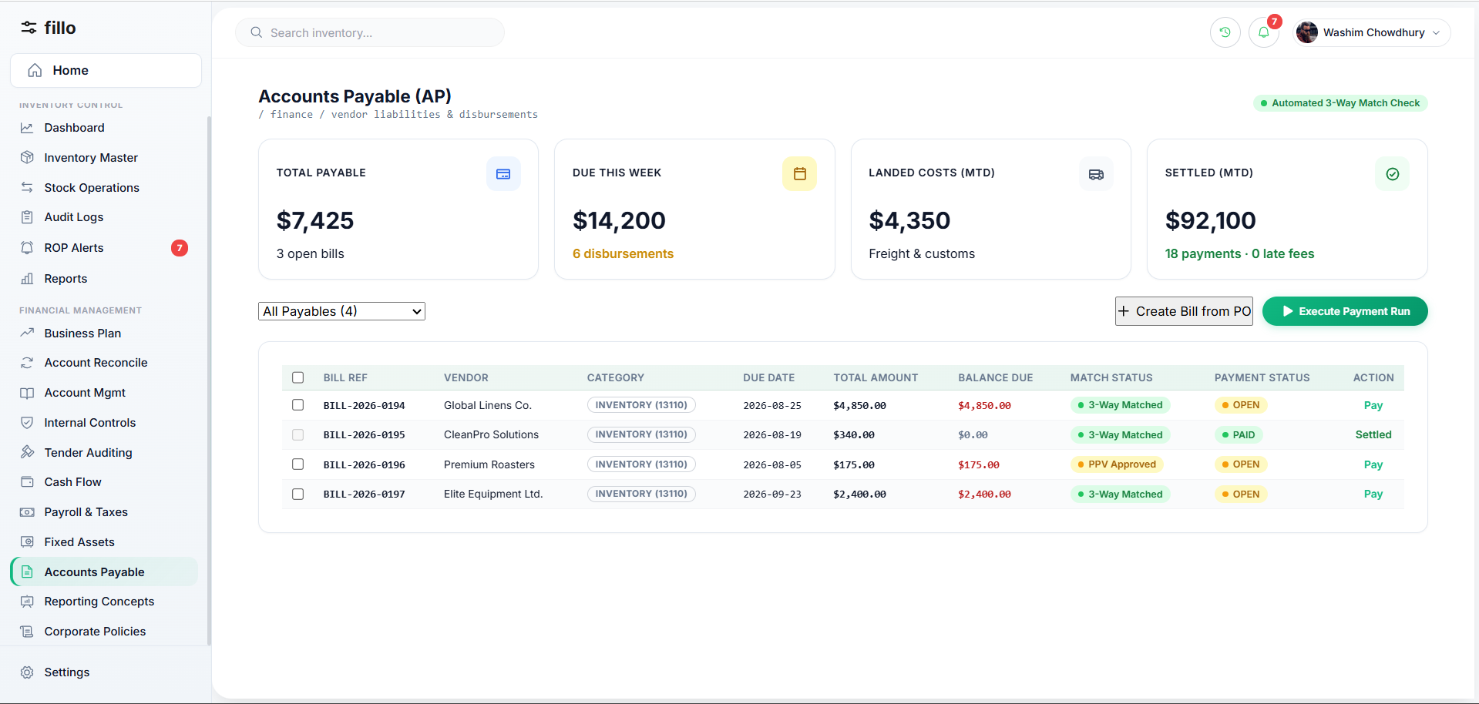
Topic 10 Feature Screenshot
Expense management captures company spending, assigns it to the correct account/category and cost center or project where relevant, verifies supporting evidence, obtains approval when required and makes the spending available for analysis.
How It Works in Practice
STEP 1  Enter or import the expense with date, amount, vendor and description. | STEP 2  Attach the invoice or receipt.
STEP 3  Classify the expense to the appropriate account/category and cost center/project where needed. | STEP 4  Route it for approval according to policy, then post the approved expense.
STEP 5
Review spending by category and period to identify trends, variances or misclassification.

Key Data & Documents  Invoices, receipts, vendor information, expense categories, cost centers/projects and approval history. | Practical Example  A JOD 500 electricity invoice is classified as Utilities Expense. At month end it is included in utilities spending and can be compared with the budget.

11 | Deduction Calculation حساب الاقتطاعات
Topic 11 Feature Screenshot
Deductions are authorized amounts subtracted from gross earnings to calculate net pay. They may be statutory or company/employee-authorized and can use fixed amounts, percentages or approved formulas.
How It Works in Practice
STEP 1  Determine gross earnings for the payroll period. | STEP 2  Identify which deductions apply to the employee.
STEP 3  Calculate each deduction using the applicable rule. | STEP 4  Total deductions and calculate net pay.
STEP 5
Show a line-by-line breakdown and handle any manual exception through an authorized, documented adjustment.

Key Data & Documents  Gross earnings, deduction types, applicability, effective calculation rules and approved manual adjustments. | Practical Example  Gross earnings are JOD 1,000. If the applicable deductions total JOD 100, net pay is JOD 900. The payslip should show each deduction separately rather than only one unexplained total.

12 | Payroll Processing / Salary Issuance إصدار الرواتب
Topic 12 Feature Screenshot
Payroll processing converts approved employee compensation inputs into reviewed and finalized salary payments. It combines gross earnings, deductions, employer contributions, approvals, payslips and the related accounting impact.
How It Works in Practice
STEP 1  Open the payroll period and load eligible employees. | STEP 2  Collect approved salary, allowance, overtime and employee-change inputs.
STEP 3  Calculate gross pay, deductions, employer contributions and net pay. | STEP 4  Review anomalies and route the payroll run for approval.
STEP 5  After approval, finalize payment, generate payslips and post the accounting entries. | STEP 6  Lock the finalized payroll; later corrections use controlled adjustments rather than rewriting history.

Key Data & Documents  Employee master data, period-specific payroll inputs, deduction/contribution rules, calculated results and approval records. | Practical Example  An employee has JOD 1,000 basic salary plus JOD 100 allowance and JOD 150 total deductions. Net pay is JOD 950. After the payroll run is reviewed and approved, payment and payslip are generated.

13 | Monitoring Tax Exemptions & Tax Updates متابعة نزول الإعفاءات والضرائب
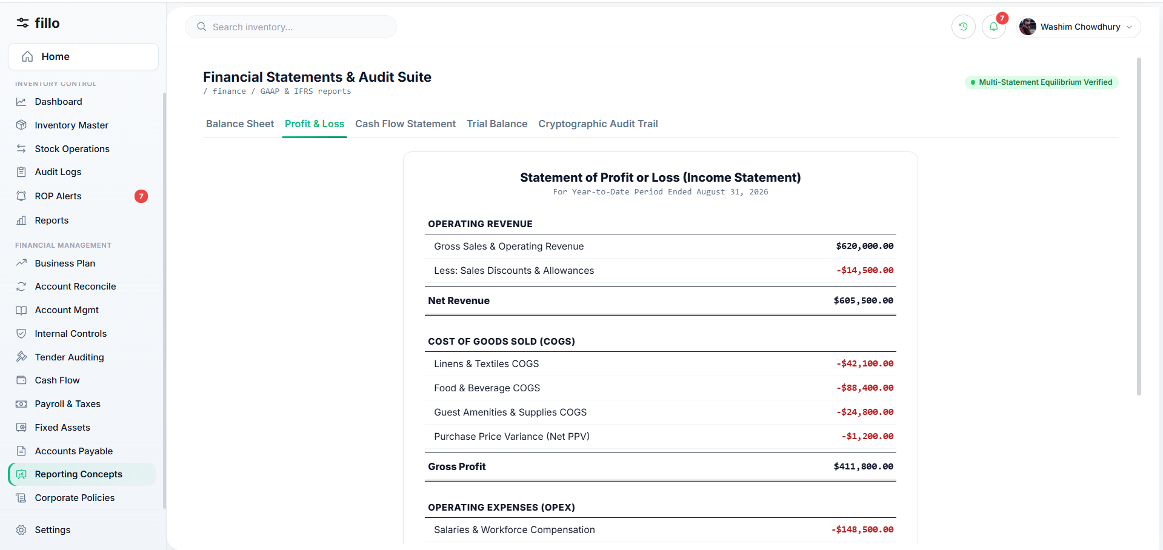
Topic 13 Feature Screenshot
Tax rates, exemptions and thresholds change over time. Finance must track approved official changes and apply each rule according to its effective date while preserving the version used for historical calculations.
How It Works in Practice
STEP 1  Review applicable official updates. | STEP 2  Record the new rule, source/reference and effective date.
STEP 3  Validate and approve the change internally before use. | STEP 4  Preserve the previous rule rather than overwriting it.
STEP 5
Apply the new version only to transactions/periods for which it is effective.

Key Data & Documents  Official notices, old/new rule values, effective dates, source references and approval history. | Practical Example  An exemption threshold changes on October 1. September calculations remain linked to the old rule, while eligible October calculations use the new approved version.

14 | Fixed Expenses المصاريف الثابتة
Topic 14 Feature Screenshot
Fixed expenses are recurring costs that remain relatively stable in the short term, such as rent, base salaries, insurance or subscriptions. They are important inputs to budgeting, cash-flow forecasting and break-even analysis.
How It Works in Practice
STEP 1  Register each recurring expense with amount, frequency, account and start/end dates. | STEP 2  Record expected payment dates so the obligation appears in cash planning.
STEP 3  Include the expected expense in budgets and forecasts. | STEP 4  When actual payment is posted, compare it with the planned amount/date.
STEP 5
Review upcoming obligations and update the schedule when contracts or amounts change.

Key Data & Documents  Recurring contracts, amount, frequency, due dates, account/cost-center and actual payment information. | Practical Example  Office rent of JOD 2,000 per month is scheduled as a recurring obligation, contributing JOD 24,000 to the annual budget and appearing in each month's expected cash outflows.

15 | Reporting Concepts التقارير
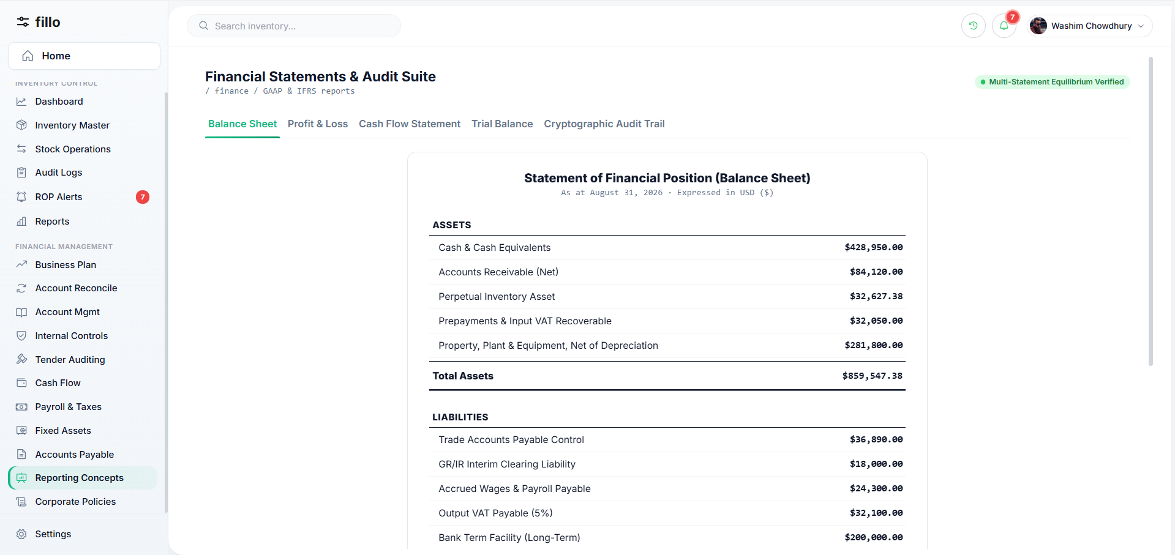
Topic 15 Feature Screenshot
15.1 Cash Flow Reports
A cash-flow report shows actual cash inflows and outflows for a selected period and the movement from opening to closing cash position. It should be based on reliable cash-account activity and allow important totals to be traced to underlying transactions.
15.2 Key Performance Indicators (KPIs)
KPIs summarize agreed financial performance measures such as profitability, liquidity or collection efficiency. The important requirement at the research stage is that every KPI must have an agreed definition, formula, data source and reporting frequency so different users calculate the same metric consistently.
15.3 Break-even Analysis
Break-even analysis identifies the sales volume at which total revenue equals total costs. It depends on fixed costs, selling price and variable cost per unit. For example, fixed costs of JOD 8,000, selling price JOD 25 and variable cost JOD 8 give a JOD 17 contribution per unit and a break-even point of approximately 471 units.
15.4 Custom Reports
Custom reporting lets authorized users answer business-specific questions by selecting permitted fields, periods, filters, grouping and sorting. Saved definitions may be reused, but access must still respect the user's data permissions.
16 | Written Financial Policy سياسة مالية مكتوبة
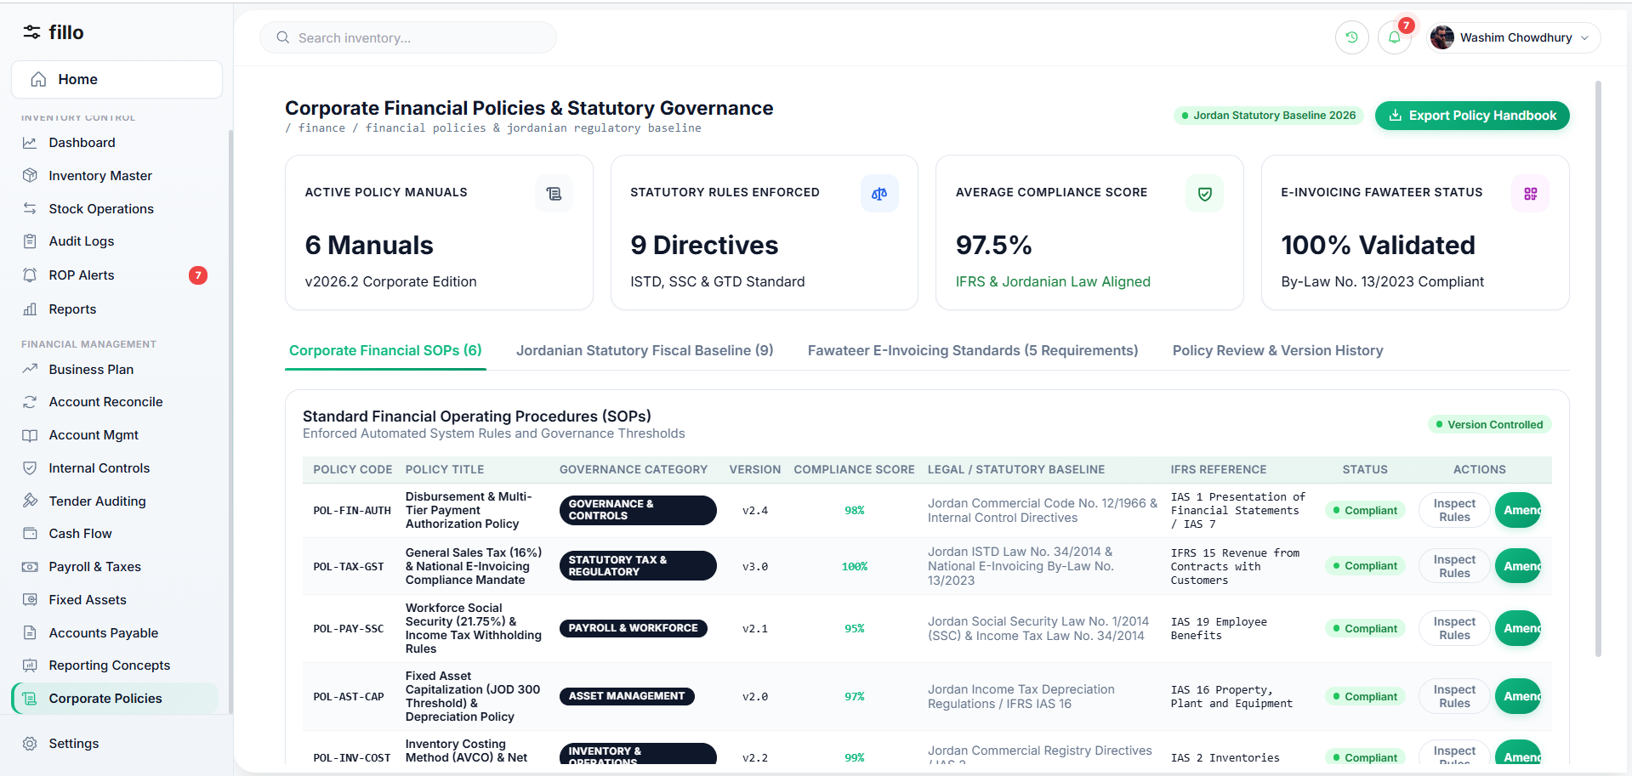
Topic 16 Feature Screenshot
A written financial policy is the management-approved set of rules governing financial operations across the company. It covers authorization limits, payments and receipts, expense rules, payroll, assets, procurement/tenders, reconciliation, reporting, tax/compliance responsibilities, record retention and accountability. The policy is the source of the rules; internal controls are the mechanisms used to enforce those rules in daily work.
How It Works in Practice
STEP 1  Management approves the policy, authority limits and approval matrix. | STEP 2  Finance converts the policy into operating procedures and control checks.
STEP 3  Employees follow the procedures; exceptions require a documented reason and appropriate review. | STEP 4  The policy is reviewed and updated through a controlled process when business or regulatory conditions change.

Practical Example
If policy requires Finance Manager approval above a defined payment threshold, a payment exceeding that threshold cannot be finalized until the approval is recorded.
17 Jordan Financial & Regulatory Baseline (2026)
Because this financial system is intended to be reusable across companies operating in Jordan, the product should include a Jordanian regulatory baseline for common taxes, statutory deductions, payroll obligations, and invoicing requirements. The values below are a current research baseline verified against official Jordanian sources as of August 2026. They must still be implemented as configurable, effective-dated rules rather than hard-coded constants.
DESIGN PRINCIPLE The software should store the rule, rate,
category, legal source, and effective date. When legislation changes,
new transactions use the new rule while historical transactions
preserve the rule that was valid at the time.

17.1 General Sales Tax (GST) - ضريبة المبيعات
Jordan applies a standard General Sales Tax rate of 16% to goods and services not subject to a reduced, zero-rated, exempt, or special-tax classification. The Income and Sales Tax Department also publishes official classifications for 0%, 2%, 4%, 5%, and 10%, as well as exemptions and special tax.
Tax treatment | Baseline rate / treatment
Standard taxable goods and services | 16%
Reduced-rate categories | 10%, 5%, 4%, or 2% according to the official classification
Zero-rated categories | 0%
Exempt goods/services | Exempt - no GST charged under the applicable exemption
Special-tax goods/services | Special rate or amount according to the official special-tax table
PRODUCT CLASSIFICATION RULE The system should not assume a broad category such as “food” or “clothing” always has one tax rate. The applicable rate should be linked to the official product/service tax classification (and tariff code where relevant).
System impact: each product or service should have a tax category, rate/treatment, effective-from date, and optional official classification/reference. Invoices should calculate GST from that configuration.
17.2 Corporate Income Tax - ضريبة دخل الشركات
Corporate income tax in Jordan varies by the company's sector. A reusable system therefore needs a company tax profile rather than one fixed corporate rate.
Company sector | Income tax rate
Industrial sector | 14%
Telecommunications; electricity generation/distribution; basic mining; insurance/reinsurance; financial intermediation/financial companies; financial leasing | 24%
Banks | 35%
Other legal persons (commercial, service, professional, etc.) | 20%
System impact: during company setup, the organization should be assigned an applicable tax sector/profile. The tax calculation should use the rate version effective for the relevant tax period.
17.3 National Contribution - المساهمة الوطنية
The National Contribution is a separate tax obligation calculated on taxable income for specified sectors/persons. It should be tracked separately from the ordinary income-tax liability.
Category | National contribution rate
Banks and electricity generation/distribution companies | 3%
Basic mining companies | 7%
Financial intermediaries, financial companies, and financial leasing legal persons | 4%
Main telecommunications, insurance, and reinsurance companies | 2%
Other legal persons | 1%
Natural persons | 1% on taxable income exceeding JOD 200,000, where applicable
System impact: Income Tax and National Contribution should be stored, calculated, reported, and settled as separate obligations, even when they use the same taxable-income base.
17.4 Withholding Tax - اقتطاع الضريبة من المصدر
Certain payments require tax to be withheld before the beneficiary receives the net amount. The applicability depends on the payment type and beneficiary status.
Common baseline case | Rate
Specified professional fees/wages paid by a resident legal person to qualifying resident professionals/civil companies | 5%
Non-exempt income due or paid to a non-resident, subject to the applicable legal provisions | 10%
Lottery/prize winnings exceeding JOD 1,000 | 15%
System impact: for a payment subject to withholding, the system should retain the gross amount, withholding category/rate, tax withheld, net amount paid, beneficiary status, and the rule version used.
17.5 Social Security - الضمان الاجتماعي
For the standard private-sector contribution structure published by the Social Security Corporation, the total monthly social-security contribution is 21.75% of the insured deductible wage, split between the employer and the insured employee.
Contribution component | Rate
Employee share: old-age/disability/death 6.50% + unemployment 1% | 7.50%
Employer share: old-age/disability/death 11% + work injury 2% + maternity 0.75% + unemployment 0.50% | 14.25%
Total standard contribution | 21.75%
Hazardous occupations | Additional 1% employer contribution where the special rule applies
System impact: payroll should calculate the employee and employer portions separately, post them to the correct accounts/liabilities, and preserve the effective contribution rule. Special categories and wage ceilings/bases should remain configurable.
17.6 Employee / Natural-Person Income Tax - ضريبة دخل الموظفين والأفراد
Employee income tax is not one flat payroll percentage. After applying the relevant personal/family exemptions and taxable-income rules, progressive brackets apply to the taxable income of a natural person.
Taxable-income band after applicable exemptions | Rate
First JOD 5,000 | 5%
Next JOD 5,000 | 10%
Next JOD 5,000 | 15%
Next JOD 5,000 | 20%
Amount above JOD 20,000 up to JOD 1,000,000 | 25%
Taxable income above JOD 1,000,000 | 30%
Current law also provides personal/family and qualifying-expense exemptions that affect the taxable base. Those details depend on the taxpayer's circumstances and should be represented as configurable payroll/tax inputs rather than one universal deduction.
Typical payroll sequence: Gross earnings -> social-security calculation -> applicable exemptions/taxable basis -> income-tax withholding -> other authorized deductions -> net salary.
17.7 Regulatory Rule Versioning
The existing Tax Updates process should be extended into a formal rule-version model. This is essential because sales-tax classifications, contribution rules, exemptions, thresholds, and tax rates can change over time.
Required rule field | Purpose
Rule Type | GST, corporate tax, national contribution, withholding, social security, payroll tax, etc.
Category / Sector | Defines who or what the rule applies to
Rate / Formula / Treatment | Numeric rate, exemption, zero-rating, special amount, or formula
Effective From / Effective To | Controls which transactions and periods use the rule
Official Source / Reference | Traceability to the law, regulation, table, or official notice
Status / Version | Active, future, expired, superseded
17.8 Jordan National E-Invoicing - نظام الفوترة الوطني الإلكتروني
Jordan operates a National E-Invoicing System under the Income and Sales Tax Department, with official procedures for registration, invoice organization, and technical linking. A financial system intended for Jordanian companies should therefore be designed so invoicing data can comply with, and where required integrate with, the national e-invoicing framework.
System impact: the Requirements/Integration phase should confirm whether the customer is obligated to join, the applicable invoice fields and numbering rules, integration method, submission/response handling, exceptions, and retention requirements. This research section establishes the capability as part of the Jordan-ready baseline; it does not define the API implementation yet.
17.9 Official Research References
• Jordan Income and Sales Tax Department (ISTD) - Tax Rates and General Sales Tax Tables (current site update, 2026).
• Jordan Income and Sales Tax Department (ISTD) - Income Tax Law No. 34 of 2014 and amendments / current law search and guidance.
• Jordan Income and Sales Tax Department (ISTD) - National Contribution and withholding guidance.
• Jordan Income and Sales Tax Department (ISTD) - Jordan National E-Invoicing System and user/technical procedure manuals.
• Social Security Corporation (SSC) - About the Corporation / private-sector monthly deduction rates and Social Security Law references.

How the Topics Connect
The topics are interconnected. Payroll uses deduction and social-security rules. Fixed expenses feed budgets, cash-flow forecasts and break-even analysis. Expense and fixed-asset data support tax preparation and reporting. Reconciliation improves the reliability of balances used by reports. Internal controls and the written financial policy govern approvals, access and accountability across all processes.
Next Step
This research provides the business foundation for the next phase of the project. The identified processes, rules, data, documents, approvals, and exceptions will be translated into clear functional requirements and system behaviors. These requirements will then be used to define User Flows, followed by Design, Back-end, and Front-end implementation.

